CONCEPT DOCUMENT FOR:

**ROCKET POP**

The Ultimate Music Action Game

**A Music Platformer Video Game for Xbox One and PS4**

**Intended ESRB Rating:** E10+ (Everyone 10 and up)

**Target Audience:** 10-25, fans of music, rhythm, platforming, and action-adventure games

**Projected Ship Date:** 2020

All work Copyright © 2018 by Eric Noce

Written by Eric Noce

Concept Document

Version # 1.00

TABLE OF CONTENTS

1 game outline 1

1.1 challenges players encounter and how to overcome them 1

1.2 how does the progression/reward system work? how do players grow as challenges increase? 1

1.3 how does the gameplay tie into the story? 1

1.4 what is the victory condition for the player? 1

1.5 the game story 1

2 characters 2

2.1 Michael Fleming 2

2.1.1 Backstory 2

2.1.2 Personality and Characteristics 2

2.1.3 Concept Art 2

2.1.4 Controls 3

2.2 Rapstar 3

2.2.1 Backstory 3

2.2.2 Personality and Characteristics 3

2.2.3 Concept Art 4

2.2.4 Controls 4

2.3 jocelyn 5

2.3.1 Backstory 5

2.3.2 Personality and Characteristics 5

2.3.3 Concept Art 5

3 gameplay 6

4 game worlds 6

4.1 area 1: los Angeles 6

4.1.1 General Description 7

4.1.2 Physical Characteristics 7

4.1.3 Levels located in this world 7

4.1.4 Music used in this world 8

4.2 Area 2: Oak Town, Oak Land 8

4.2.1 General Description 8

4.2.2 Physical Characteristics 8

4.2.3 Levels located in this world 8

4.2.4 Music used in this world 8

4.3 Area 3: Cheeky Mountains 9

4.3.1 General Description 9

4.3.2 Physical Characteristics 9

4.3.3 Levels located in this world 9

4.3.4 Music used in this world 9

5 game experience 10

5.1 what is first seen when the game starts up? 10

5.2 emotions/moods meant to be invoked 10

5.3 use of music and sound to convey emotion 10

5.4 shell of game 11

6 gameplay mechanics 11

6.1 mechanics 11

6.2 hazards 11

6.3 powerups 12

6.3.1 Swag Points 12

6.3.2 Slow Down! 12

6.3.3 Slow-Mo 12

6.3.4 Freeze! 12

6.4 collectibles 12

7 enemies 12

7.1 boss characters 12

7.1.1 Mr. Drain 12

7.2 enemies with ai 13

7.2.1 Musical Robots 13

7.2.2 The Treble 200 14

7.2.3 Ice Monsters 14

8 bonus materials 14

8.1 unlockables 14

8.2 achievements 15

8.3 “refresh my memory” 15

9 additional gameplay modes 15

9.1 versus mode 15

9.2 singing tournament mode 16

9.3 free play mode 16

10 monetization 16

**----------------------------------------------**

**1 Game Outline**

**----------------------------------------------**

**1.1 Challenges players encounter and how to overcome them**

In the 3D action platform levels, players are typically given the task of reaching a certain destination, having to contend with enemies and/or bosses along the way. Once the player reaches the destination or defeats a key boss, they complete that level. It is also possible that the player will be swarmed by paparazzi, but these will be easy to evade.

In the music levels, players will generally be required to tap the buttons on their controller in time with the music. The four buttons on the far right of the controller would be the only buttons used for these levels, to simplify the gameplay. In most cases, the player must score higher than their opponent to advance.

**1.2 How does the progression/reward system work? How do players grow as challenges increase?**

In order to complete a level, players must complete the objective that is shown onscreen at the start of that level. As the player progresses through the game, each of the levels get slightly harder as they learn the game and improve with the controls. Essentially, the game is designed to “train” the players; they begin with simpler levels but then move on to more difficult levels as they learn the controls of the game.

**1.3 How does the gameplay tie into the story?**

The player controls Michael and his friends through a variety of levels and challenges in order to defeat Mr. Drain and rescue Jocelyn and all of the stolen celebrity voices. These levels and challenges are spread across Los Angeles and Oak Land, the latter in an alternate dimension of Earth where only anthropomorphic animals exist. Tension builds as more enemies are defeated and the characters must alternate between worlds. Things also get more difficult for the player as levels progress.

**1.4 What is the victory condition for the player?**

The ultimate win condition of the game is for the player to locate Mr. Drain and defeat him in a final battle. After this condition is reached, all of the stolen voices are freed and returned to their respective owners. Then Michael and Jocelyn happily reunite and they leave the site of the battle.

**1.5 The Game Story**

In a world where humans and anthropomorphic animals coexist, Michael Fleming is a famous porcupine pop star famous for birthing, a new, unique version of pop music known as “Rocket Pop.” One day, a jealous, little-known recording artist named Mr. Drain starts stealing the voices of numerous world-famous celebrities, including Michael’s girlfriend, fellow pop star Jocelyn. Michael, determined to rescue his girlfriend and all of the stolen voices, sets out to uncover a route to Mr. Drain so he can face off with him. Along the way, he is forced to confront hordes of Mr. Drain’s minions, mostly robots, face off against his rival, Rapstar and an “Icicle Chimp” clan in the Cheeky Mountains to gain their respect and progress past them, and face “reverse” versions of himself.

**----------------------------------------------**

**2 Characters**

**----------------------------------------------**

**2.1 Michael Fleming**

The main character in the story. He is a yellow porcupine pop star famous for introducing a new version of pop music known as “Rocket Pop.” The player controls him throughout the majority of the game, with occasional exceptions. His very first appearance is right at the beginning of the game, in the second cut scene, where Mr. Drain steals Jocelyn’s voice while she and Michael are hosting a concert.

**2.1.1 Backstory**

19 years ago, this porcupine celebrity was born in the fictional world of Oak Land to two porcupine parents. He was extremely intelligent right from when he was as young as 2 years old, and always got straight A’s or A+’s when he was in school. As he grew up in Oak Land, however, he had several life-changing experiences, losing his parents and brothers. One day, he met Jocelyn and they fell in love.

He became famous when he landed a recording deal with Universal Music Group. He became extremely popular, and later moved to the United States, settling in Malibu, just outside Los Angeles. However, he continued to attend high school in Oak Land until his graduation.

**2.1.2 Personality and Characteristics**

Loves music, singing, and dancing. Wants to live a happy celebrity life. Very energetic and determined. Will not give up easily. Cheerful. Wants to serve as a good role model for others. Fears losing someone close to him as he did on more than one occasion.

**2.1.3 Concept Art**

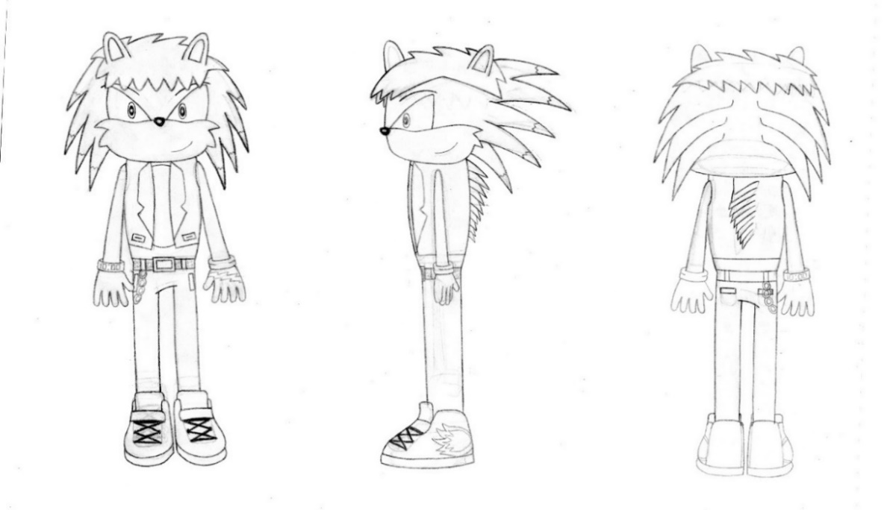

**Figure 1: Michael Fleming’s full turnaround sheet**

His skin colour is yellow. His muzzle and chest are coloured light apricot. His gloves are blue.

**2.1.4 Controls**

The controls vary based on the type of level the player is on, and the console the game is being played on.

If the player is on a 3D action platformer level, they must use the right joystick to move Michael around. They can rotate the camera 360 degrees with the left joystick. (Applies to both consoles.) Pressing triangle (PS4) or Y (Xbox One) makes him jump. Pressing circle or B makes him sing kind of off-tune.

If the player is on a music level with guideways, then the only controls are the four buttons on the far right side of the controller. On the PS4, these buttons are square, triangle, circle, and X, while on the Xbox One, these buttons are X, Y, B, and A.

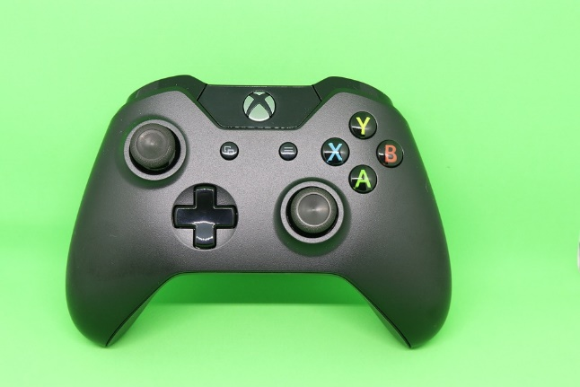



**Figure 2: Xbox One controller above, PS4 controller below**

**2.2 Rapstar**

Michael’s main rival, this 22-year old white tiger is a famous rapper. The player takes control of him at occasional points in the story when Michael does not yet have the right skills. His very first appearance is after the first couple of challenges, when Michael goes to his mansion to ask for his help.

**2.2.1 Backstory**

As a child, Rapstar grew up playing sports, making it a regular hobby of his. He met his best friend, Cappuccino, while they were playing basketball one time. The two practiced rapping and had rap battles sometimes. Years later, Rapstar landed his first recording deal and moved to the Hollywood Hills. Today, he is very affluent.

**2.2.2 Personality and Characteristics**

Snobby and somewhat short-tempered, but brave and courageous. Very muscular. Loves sports, especially basketball and hockey. Somewhat more energetic than Michael. Will only agree to help Michael if he meets his demands, such as beating him in a face-off or giving him enough Bass Points. Loves to show off. Superior stamina.

**2.2.3 Concept Art**

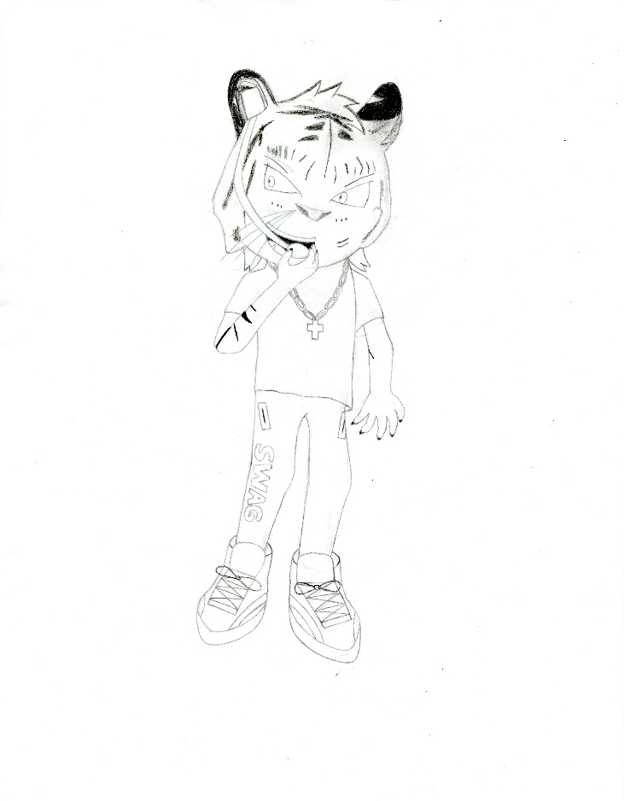

**Figure 3: Rapstar concept art**

His skin colour is white, with black streaks. He usually wears a white t-shirt or a sports jersey, often with a chain on his neck. Sometimes, he will wear pants, other times he will wear shorts.

**2.2.4 Controls**

If the player is on a 3D action platformer level, Rapstar, unlike Michael, uses his strength rather than his voice. The player still uses both joysticks to move him and the camera, just like with Michael.

If the player is on a music level with guideways, then the only controls are the four buttons on the far right side of the controller. On the PS4, these buttons are square, triangle, circle, and X, while on the Xbox One, these buttons are A, B, X, and Y.

**2.3 Jocelyn**

Michael’s girlfriend, another famous pop star who plays the role of the damsel in distress. Her very first appearance is right at the beginning of the game, in the second cut scene, where Mr. Drain steals her voice while she and Michael are hosting a concert. Non-playable character (NPC).

**2.3.1 Backstory**

She grew up to parents who mostly ignored her. One day, many years later, she landed a recording deal on live TV after winning a talent show.

**2.3.2 Personality and Characteristics**

Passionate about her relationship with Michael. Very outgoing and somewhat of a diva, but tries to be a good role model just like her boyfriend.

**2.3.3 Concept Art**

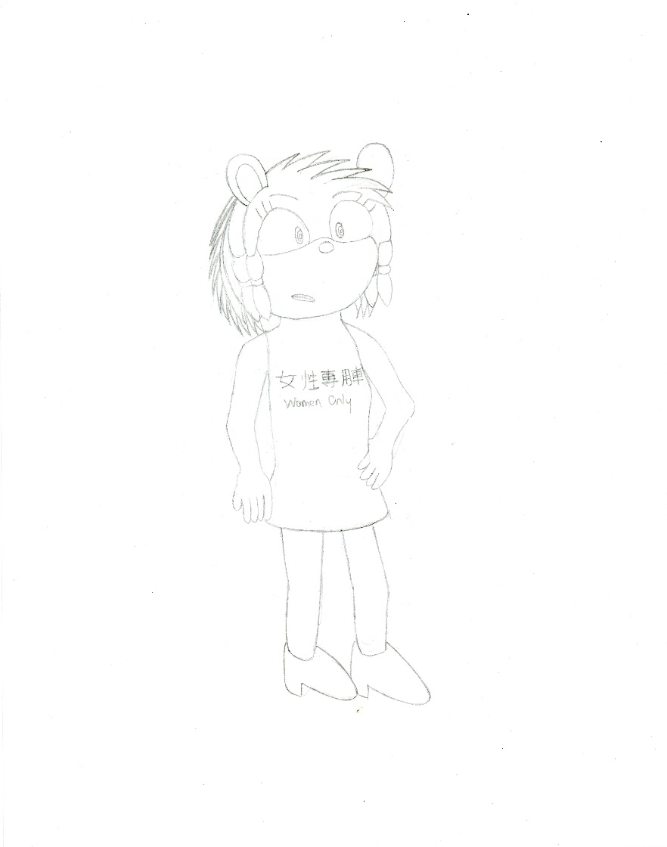

**Figure 4: Jocelyn concept art**

Her skin colour is purple. Her dress is pink. Her slippers are red.

**----------------------------------------------**

**3 Gameplay**

**----------------------------------------------**

The player must control Michael through Los Angeles and his home of Oak Land, in another dimension of Earth. The game alternates between the two worlds as the player progresses. The game is divided by levels, which the player must complete in a specified order to progress to the next level. Defeating enemies and completing challenges will earn him “Bass Points,” which he can spend on upgrades and new skills.

In the 3D action game levels, Michael must use his strong steps to combat and defeat hordes of Mr. Drain’s powerful, but sensitive, robots. He must navigate to the destination within the time limit and avoid taking too much damage. If he can go for long enough without taking any damage, his health will slowly replenish itself. In some levels, he must also search for a specific character to challenge them to a faceoff. There will be directional maps to help the player navigate these kinds of levels. Gameplay elements resemble those of *Sonic the Hedgehog* and *Ratchet and Clank* games. There is also a possibility that Michael will be pursued by paparazzi, but it will be easy to escape them, to avoid frustrating the player.

In the music levels, there are typically four “guideways” on the bottom of the screen. At the end of each guideway is the button that the player must push whenever there is an icon sliding down that guideway. The icons that move down the guideways are icons of Michael’s face, and the player must push the correct button in time with the music that is playing once the icon reaches the bottom of the screen. Longer “Snake Icons” require the player to hold down that button. The player scores more points for better timing. Enough well-timed consecutive button pushes can also start a “streak” which earns them even more points. The player must meet the objective of the level, using scoring higher than their opponent, to progress. Gameplay elements resemble those of *Superbeat: Xonic*, except the controls here are far easier.

Some levels require the player to play as a different character with suitable characteristics for that level, almost always Rapstar, but the game switches characters automatically so that the player does not have to do it themselves.

**----------------------------------------------**

**4 Game Worlds**

**----------------------------------------------**

**4.1 Area 1: Los Angeles**

This entire world is a detailed, real-life simulation of the City of Los Angeles.

**4.1.1 General Description**

Los Angeles, located in southern California, is the state’s largest city, and the second largest city in the United States. It is a major centre of the entertainment industry, with Hollywood being a hotspot for hopeful celebrity-spotters, and the home of many record labels and movie studios. Notable suburbs include Beverly Hills (for its shopping, particularly along Rodeo Drive), Santa Monica (for its tourist attractions such as beaches and numerous restaurants), and Anaheim (for its Disneyland Resort). Well-known landmarks include the Hollywood sign. Most people living in this well-developed metropolitan area of the United States enjoy a high standard of living, and there is never a shortage of any essential resource such as food, water, or electricity. Human rights are generally good, with democracy, freedom of religion, and free trade thriving.

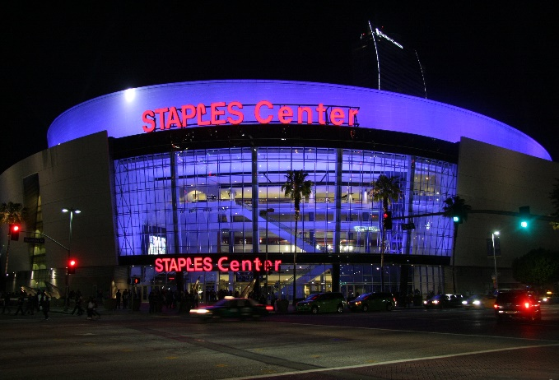

**Figure 5: Many big-name celebrities perform at the Staples Center.**

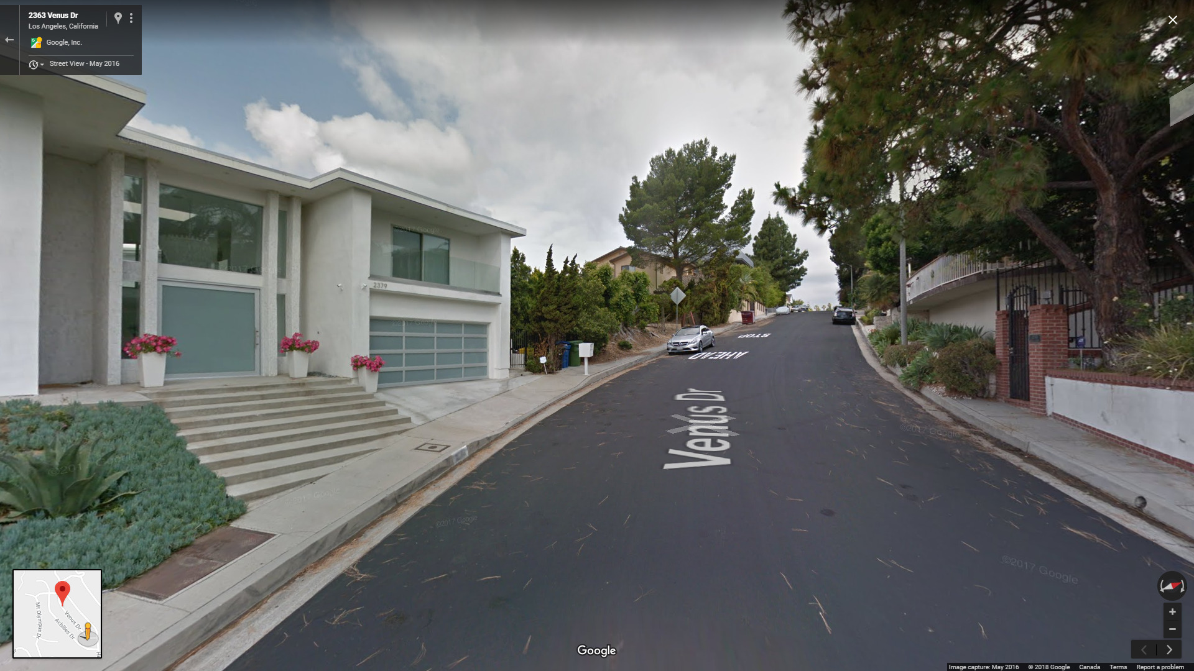

**Figure 6: The Hollywood Hills is an affluent residential neighbourhood.**

**4.1.2 Physical Characteristics**

The Los Angeles Metropolitan Area is surrounded by the Pacific Ocean to the west, and there are numerous beaches as a result. Most of the city and its suburbs are located on flat land. Some neighbourhoods, such as the Hollywood Hills, are located farther above sea level than others.

**4.1.3 Levels located in this world**

Overall, the levels in this world typically require the player to traverse large swaths of Greater Los Angeles.

The very first level of this world is a slow-paced tutorial level to teach the player the basics of platforming levels. It is somewhat open-world, but more linear, as Michael does not have an unlimited range of movement here and is only confined to certain areas.

The first music level is also a slow-paced tutorial level designed to teach the player the basics of those levels. Michael is visible on the screen, but the player does not have control of him like in other levels. Here, he sings against his opponent, and the player must match the music by tapping the buttons in time with the on-screen icons of his face.

**4.1.4 Music used in this world**

For the entire duration of this world, intense pop music, with a hint of heavy metal, will play. This is intended to give the player the feeling of a confrontation.

**4.2 Area 2: Oak Town, Oak Land**

This area, in an alternate dimension of the planet, can only be accessed by touching a certain kind of magical flower. One of several areas in Oak Land, a world inhabited only by anthropomorphic animals, mostly rodents, and Michael hails from here. Mr. Drain launches an attack as soon as Michael arrives.

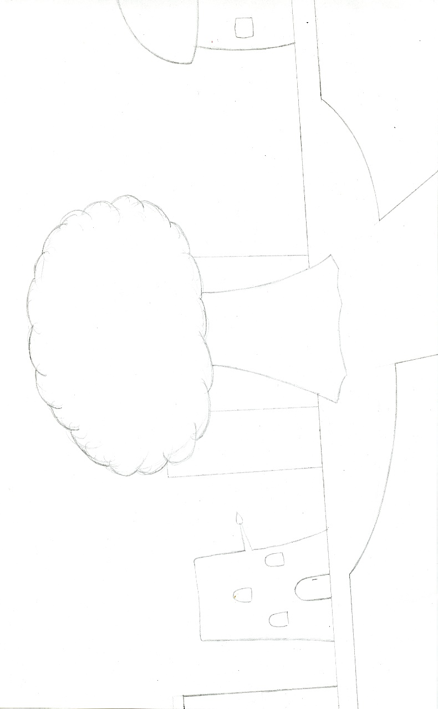

**Figure 7: Rough sketch of the centre of Oak Town, marked by a giant tree sitting in the centre of the pedestrian junction.**

**4.2.1 General Description**

Oak Town is a mostly low-rise, tranquil, and fairly quiet town. There are flowers and eco-friendly buildings spread all over this town. Everyone enjoys high standards of living.

**4.2.2 Physical Characteristics**

This town mostly consists of trees and steel-and-glass buildings. Some of the trees are actually inhabited by several of the town’s citizens. In the centre of this town is a mostly residential area dominated by trees.

**4.2.3 Levels located in this world**

The first level that is located in this world is located in the centre of Oak Town, where Mr. Drain has started stealing the voices of some of Michael’s fellow celebrities in the town.

**4.2.4 Music used in this world**

For the entire duration of this world, a combination of intense pop music and more relaxing R&B music will play. Contrasts Oak Land’s easygoing, friendly nature with the Mr. Drain-orchestrated invasion.

**4.3 Area 3: Cheeky Mountains, Oak Land**

This area is also part of Oak Land, although a long walk away from Oak Town.

**4.3.1 General Description**

The Cheeky Mountains are a very cold mountain range miles from anywhere in Oak Land. It is inhabited by a kingdom of “Icicle Monkeys,” known for being conservative and isolated from the outside world. They do not like others trespassing on land they claim to be theirs.

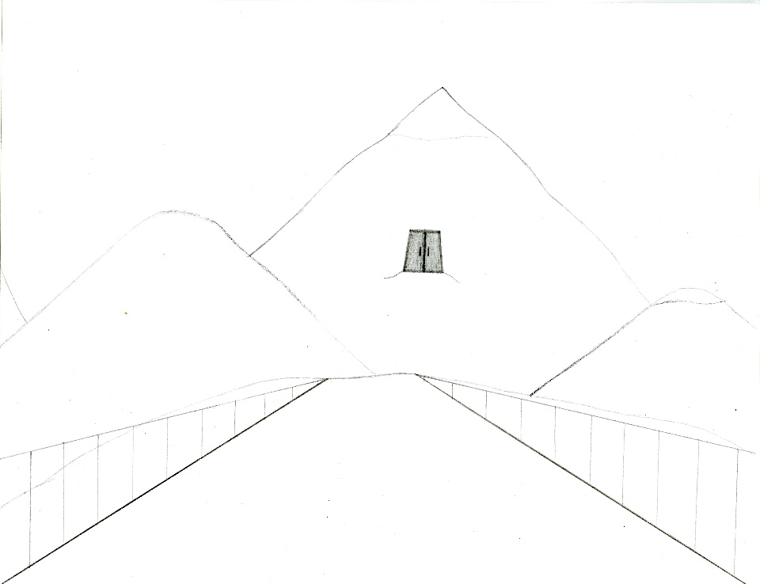

**Figure 8: Rough sketch of the Cheeky Mountains. The entrance to the Icicle Chimps’ colony is marked by the dark door.**

**4.3.2 Physical Characteristics**

This land only has mountains. It is very mountainous, with little flat land. Some mountains have snow-capped peaks. The Icicle Chimps inhabit a kingdom in this region, but it is hidden, with the only way inside being the giant door a significant climb up the tallest mountain in the range.

**4.3.3 Levels located in this world**

Michael and Rapstar must face off against the Icicle Chimps to convince them to let them go. Here, the player is tasked with controlling Rapstar in a rhythm game-style level where he moves around on a skating rink, and if the player misses notes, he can mess up and potentially fail the challenge. Other challenges include swarms of hostile ice monsters.

**4.3.4 Music used in this world**

For the entire duration of this world, pop music, with a hint of Christmas music (i.e. bells ringing), will play. This is intended to suit the theme of winter that is associated with the Cheeky Mountains.

**----------------------------------------------**

**5 Game Experience**

**----------------------------------------------**

**5.1 What is first seen when the game starts up?**

When the player starts up the game from the PS4 or Xbox One menu, the first thing that is seen is the startup screen, which has a picture of Michael on a stage singing, with bright lights illuminating the background and the stage, like a concert, and the game’s logo on that screen. After this, the company logo would appear, along with the logo of the game engine that was used to develop this game. Finally, the game’s copyright information would appear before the title screen.

On the title screen, the player will be presented with a very brief opening cutscene in which Michael is standing on a stage. He shouts into the microphone, “ROCKET POPPPPPPPPP!!” At the same time, the game’s title, written in big sky blue letters, shoots out of the microphone, twirling and twisting before crashing into a wall as a groovy electropop beat plays in the background. After this, the words “Press Start” appear, and the player must press Start to begin the game. On the menu screen, they see all of the options available to them, including all of the game modes, the Inventory, Character Profiles, a “Refresh My Memory” tutorial that players can access at any time, and the Options.

**5.2 Emotions/Moods meant to be invoked**

The highly detailed simulation of Los Angeles is meant to provide a deep sense of realism and make players feel like they are right at home (if they hail from Greater Los Angeles or know the area well enough). Additionally, Los Angeles is a city inhabited by many celebrities. The title screen and the startup screen are meant to invoke the feeling that this game revolves around pop music, which it does. However, the only AI in the game that Michael can really interact with is the enemies, which he is required to destroy.

The controls for this game are fairly simplified compared to other games of these genres, which is designed to provide an even more soothing game experience, because there is not as much learning to be done. This also decreases the amount of frustration the player will feel while playing the game.

**5.3 Use of music and sound to convey emotion**

The music on the title screen would be pop music with fast, intense beats, which makes heavy use of bass and an electronic piano synthesizer. This is the imaginary definition of “Rocket Pop,” the “new” version of pop music that Michael is famous for introducing. This music is designed to make the players happy and give them a feeling of what is to come as they play the game. The use of this kind of music is also intended to make the game more “fun” for the player because music is enjoyed by people of many demographics especially teens and young adults.

**5.4 Shell of Game**

Start

New Game

Load Saved Game

Story Mode

Start Up Game

Versus Mode

Title Screens/Copyright Info

Rules/player choices

Select # of players

Singing Tournament Mode

Main Menu

Free Play Mode

View items/clothes obtained

Inventory

Choose a character profile

Character Profiles

Begin tutorial

Refresh My Memory

Options

**Figure 9: General flow of the main menu.**

**----------------------------------------------**

**6 Gameplay Mechanics**

**----------------------------------------------**

**6.1 Mechanics**

Players regularly interact with enemies by stomping on them or defeating them with Michael’s voice. The players interact with certain enemies and boss characters by facing off against them in the rhythm game-style levels.

**6.2 Hazards**

There are no hazards in this game that do not have artificial intelligence. Only moving enemies and the projectiles that some of them shoot can deplete the character’s HP.

**6.3 Powerups**

During the music levels, there are some powerups available, but only one powerup can be deployed at a time. If a second one becomes available, the player must wait until the current one wears off before they can deploy it.

**6.3.1 Swag Points**

Earned by scoring enough points in a row. When the player has enough Swag Points, Super Mode automatically activates, doubling their score for thirty seconds. Not available in every music level. Can be used to unlock some clothing items.

**6.3.2 Slow Down!**

Only available during fast enough songs. This powerup slows down the music like a remix, making it easier for the player to tap the buttons in time with the icons, and possibly score bigger chains. To get it, get 50 Perfect! or Great! judgements in a row.

**6.3.3 Slow-Mo**

Everything happens in slow-motion. This powerup makes it very easy to hit every note. To get it, get 70 Perfect! or Great! judgements in a row. Increases to 100 in a row in later levels. Wears off after 25 seconds.

**6.3.4 Freeze!**

This powerup freezes one of the opponent’s guideways, substantially reducing the number of notes that they have to press, giving the player a scoring advantage. The frozen guideway thaws after 10 seconds.

**6.4 Collectibles**

By defeating enemies and completing challenges, the player can earn “Bass Points,” which they can spend on upgrades and new skills for Michael, and some for Rapstar, to help them later on in the game. Some of these include more stamina and muscle, faster speed, and special collectibles.

**----------------------------------------------**

**7 Enemies**

**----------------------------------------------**

**7.1 Boss Characters**

**7.1.1 Mr. Drain**

A little-known recording artist who grew up in poverty, he has tried, without success, to build a life for himself as a celebrity. Taught himself engineering growing up. He is very jealous of Michael Fleming and other world-famous celebrities, so using his engineering skills, he builds machines that can steal celebrity voices.

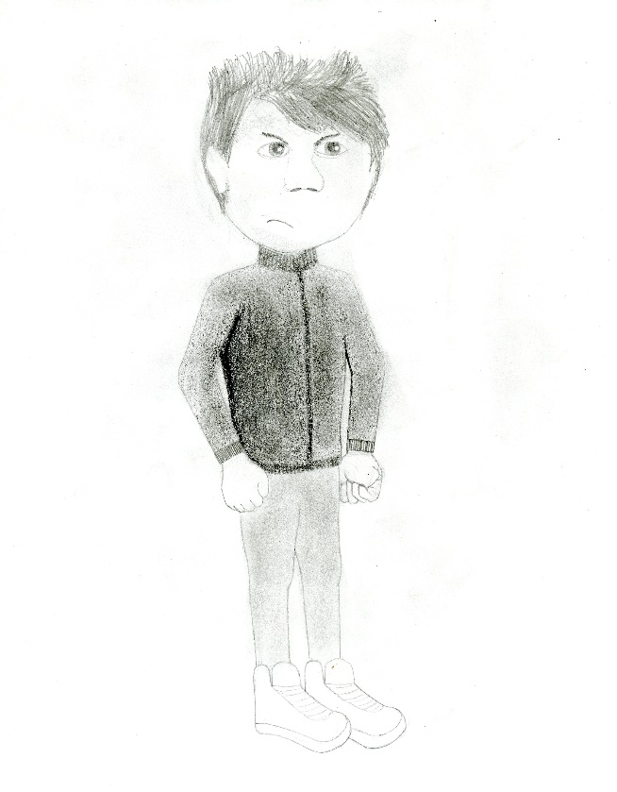

**Figure 10: Sketch of the jealous Mr. Drain.**

His jacket colour is purple. His skin is relatively pale. His hair is not very well groomed and his jeans are ripped.

**7.2 Enemies With AI**

**7.2.1 Musical Robots**

The main kind of enemy in the game, Musical Robots are aggressive robots created by Mr. Drain whose soundwaves can cause damage to the player. However, they are sensitive to certain types of music and have a manufacturing defect that makes them fairly easy to destroy. Therefore, they can short-circuit and explode if Michael sings close enough to them.

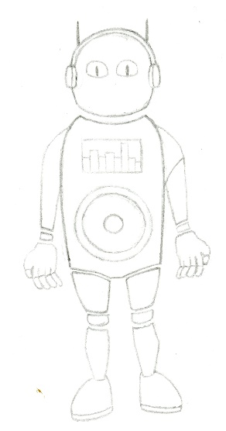

**Figure 11: Sketch of a Musical Robot.**

**7.2.2 The Treble 100**

Much stronger kind of robot. Can only be destroyed by using muscle, a skill which Rapstar naturally possesses, but he only agrees to train Michael if the player has enough Bass Points to spend.

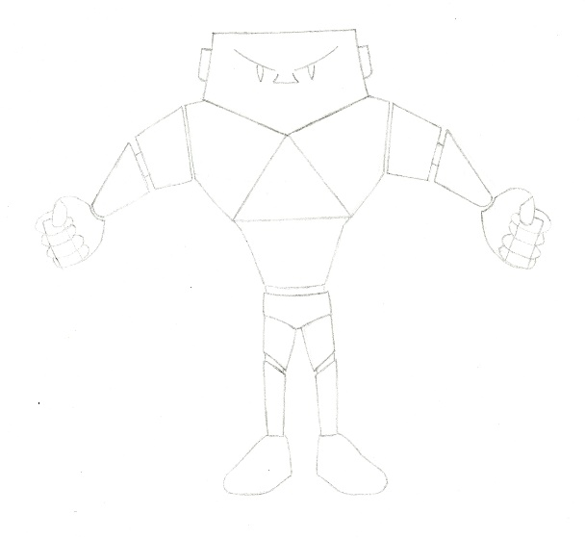

**Figure 12: Sketch of a Treble 100.**

**7.2.3 Ice Monsters**

These monsters only inhabit the Cheeky Mountains. Their freezing breath can weaken the character’s muscles, thus slowing down their movements temporarily and making it harder to attack enemies.

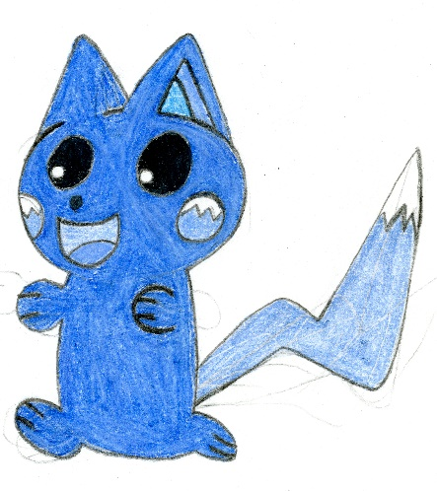

**Figure 13: Sketch of a blue Ice Monster.**

**----------------------------------------------**

**8 Bonus Materials**

**----------------------------------------------**

**8.1 Unlockables**

After the player has earned a minimum number of Bass Points, they unlock the Shop, which can be accessed from the Pause Menu anytime they wish. Here, the player can spend their Bass Points on certain upgrades for Michael and Rapstar, as well as clothes and accessories for multiplayer modes. The player can also spend some of their Bass Points to have Michael go through strength training with Rapstar.

Free Play Mode is one of the game’s three multiplayer modes. It is unlocked once the player progresses past the halfway point in Story Mode. When this mode is first unlocked, a limited number of songs from the game are available, but more songs become available as the player progresses beyond the halfway point of Story Mode.

Additionally, there are many clothes that can be unlocked and added to the wardrobe for the game’s Singing Tournament Mode, where players can choose to change the outfit of one of the game’s characters, or they can build their own animal celebrity. Headpieces, chains, and shoes are also available.

**8.2 Achievements**

There are also a few key achievements to be accomplished. Completing the game requires the player to defeat Mr. Drain and rescue all of the stolen celebrity voices. Unlocking all of the clothing and accessories requires the player to obtain every piece of clothing and every accessory that is available to be unlocked in the game. The player must obtain these clothes through various ways, such as spending Bass Points, completing certain challenges, or making other achievements.

**8.3 “Refresh My Memory”**

This is a tutorial exclusive to the game’s main menu. By selecting it, players who have forgotten the controls or are new to the game can view this tutorial without having to play the game over again. This tutorial provides a quick recap of all the controls in the game and how they vary based on the type of level. It places the player in the beginning levels and re-explains the controls, then gives them time to practice the controls again. The player can access this tutorial from the main menu as many times as they want.

**----------------------------------------------**

**9 Additional Gameplay Modes**

**----------------------------------------------**

**9.1 Versus Mode**

This mode is for a minimum of two players and up to four players. The players compete against each other in rhythm game-style stages like the ones in Story Mode. Whichever player gets the highest score wins.

The settings can be altered depending on how many games the players want to play. The players can choose a set number of games to play, and the champion is the player that wins the most games. The “First to 3” option changes the ultimate win condition to a total of 3 games won. The “First to 4” option changes the ultimate win condition to a total of 4 games won.

**9.2 Singing Tournament Mode**

This mode is for a minimum of two players and up to four players. In this mode, everyone competes against each other in a singing tournament. Players take turns controlling a character performing a song in rhythm game-style stages, and the one with the highest score advances to the next round. There are also a large amount of CPU players taking part in every tournament, unless it is online.

In the Online version of this mode, players can go online to participate in singing tournaments with other players not in the same room as them. This mode would require an internet connection and enough players playing online at once.

Players also have the option to make their own animal celebrity using the “Custom Character” option. To create their animal celebrity, they are first given a choice of animals to choose from before they are taken to the wardrobe. Here, they have a choice of numerous clothes and accessories, which grows as more progress is made in Story Mode and more achievements are reached. The player can combine any clothes they want, but the better their character’s clothes match, the more quickly the player can earn Swag Points while playing with that character.

**9.3 Free Play Mode**

This mode is for a minimum of one player and up to four players. Here, players can choose any song from the game that they want to perform. This mode becomes available after the halfway point in Story Mode, with a limited number of available songs to begin with. New songs are unlocked as the player progresses beyond the halfway point in Story Mode.

**----------------------------------------------**

**10 Monetization**

**----------------------------------------------**

With their money, players would be buying their own copy of “The Ultimate Music Action Game Like No Other!” Playing this game would give players time to help Michael reach his goal of rescuing all of the stolen celebrity voices. It would also give them a chance to customize their own animal celebrity and play with friends.

This game would also sell for $50 up front. Given the high lifetime sales figures for the PS4 and the Xbox One (as of September 1, 81 million and 38 million, respectively), there is considerable market potential and opportunity for this game to reach and appeal to a wide audience.